**React Project Structure**

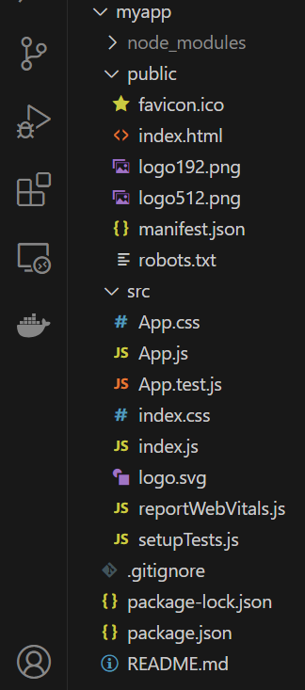

Here's an overview of each file and directory in the

This structure is set up by Create React App (CRA) to give developers a quick start with React

1. **node_modules:** This directory contains all the dependencies and libraries required for your project. These get installed when you run **npm install.**

2**. public:** Holds static files and assets that don't go through Webpack.

* **favicon.ico:** The small icon displayed next to your website's title in browser tabs.
* **index.html:** The main HTML file. React will inject its components into a div with an id of "root" inside this file.
* **logo192.png & logo512.png:** Logo images in different resolutions, often used for app icons on various devices and in the browser.
* **manifest.json:** Provides information about the application (like name, author, description, and more) in a JSON format. It's used when you want to make your web app installable as a Progressive Web App (PWA).
* **robots.txt:** A file used by search engines to understand which pages or sections of your site shouldn't be crawled or indexed.

3. **src:** The primary directory where your React source code resides.

* + **App.css:** Contains the styles for the App component.
  + **App.js:** The main React component for your application.
  + **App.test.js:** Contains tests related to the App component, utilizing Jest, the testing tool that comes with Create React App (CRA).
  + **index.css:** Contains global styles for your application.
  + **index.js:** The JavaScript entry point file. It initializes the React application and renders the App component.
  + **logo.svg:** A default SVG logo provided by CRA.
  + **reportWebVitals.js:** A utility for measuring and reporting web page performance.
  + **setupTests.js:** Configuration for setting up tests in the CRA environment.

4. **.gitignore:** Specifies which files or directories should be ignored by Git. For instance, **node_modules** is typically excluded from being tracked because it contains a large number of files and can be re-created by running `npm install`.

5. **package-lock.json:** Automatically generated by npm. It ensures that installations are consistent across different environments by detailing the exact version and configuration of installed packages.

6. **package.json:** Defines the project dependencies, scripts, and other metadata. It's a crucial file for npm and yarn to know which packages to install and how to run certain tasks.

7. **README.md:** A documentation file written in Markdown format. It usually provides an introduction to the application, how to run it, and other related information.